Cryptocurrency
# Source: AI Source: Provided by: [Data Path: Persons Table -> ID Column: 1, Name_En Column: Motasem Essam] -> From: [ChatGPT] on [7/17/2026]






Cryptocurrency is a type of digital currency that uses cryptography to secure transactions, verify ownership, and control the creation of new units. Unlike traditional currencies issued by governments or central banks, most cryptocurrencies operate on decentralized blockchain networks maintained by participants around the world.

Definition
# Source: AI Source: Provided by: [Data Path: Persons Table -> ID Column: 1, Name_En Column: Motasem Essam] -> From: [ChatGPT] on [7/17/2026]
Cryptocurrency is a decentralized digital currency that uses cryptographic techniques and blockchain technology to securely record transactions and transfer value without requiring a central authority.

Origin of the Name
# Source: AI Source: Provided by: [Data Path: Persons Table -> ID Column: 1, Name_En Column: Motasem Essam] -> From: [ChatGPT] on [7/17/2026]
The word Cryptocurrency combines:
- Crypto → Cryptography (security through encryption)
- Currency → A medium of exchange
Its security relies on advanced cryptographic methods.

Characteristics of Cryptocurrency
# Source: AI Source: Provided by: [Data Path: Persons Table -> ID Column: 1, Name_En Column: Motasem Essam] -> From: [ChatGPT] on [7/17/2026]
Cryptocurrencies are generally:
- Digital only (no physical coins or banknotes)
- Decentralized (for most major cryptocurrencies)
- Secured using cryptography
- Recorded on a blockchain
- Transferable worldwide over the internet
- Accessible through digital wallets

Blockchain Technology
# Source: AI Source: Provided by: [Data Path: Persons Table -> ID Column: 1, Name_En Column: Motasem Essam] -> From: [ChatGPT] on [7/17/2026]
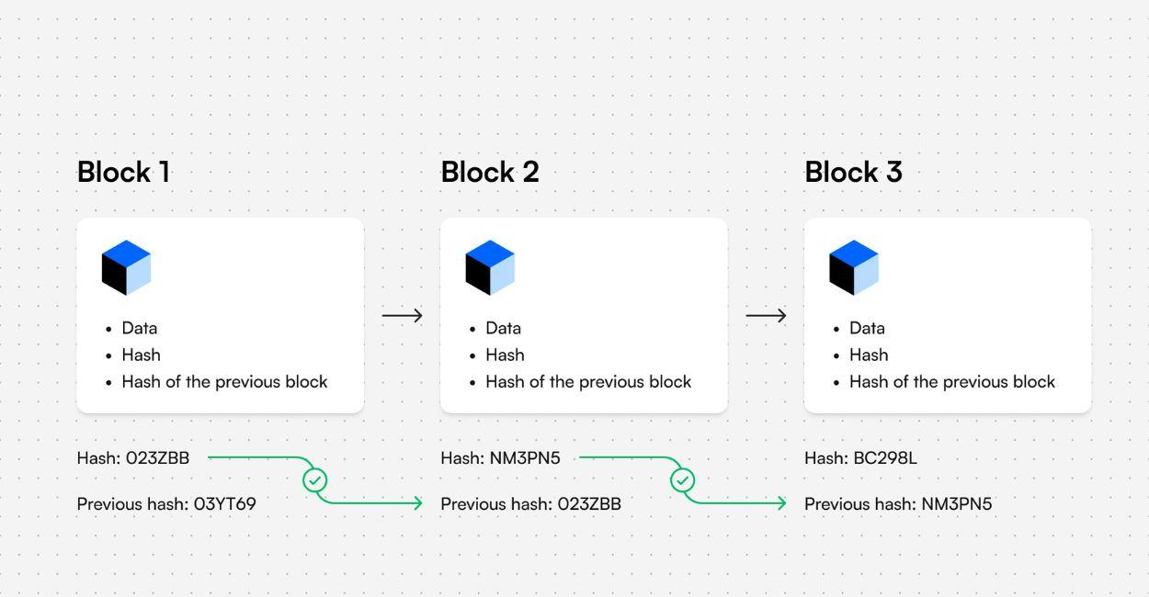




Most cryptocurrencies use a blockchain, a distributed digital ledger that records transactions.
A blockchain:
- Stores transactions in blocks.
- Links blocks chronologically.
- Is maintained by many computers (nodes).
- Makes confirmed transaction records extremely difficult to alter.

How Cryptocurrency Works
# Source: AI Source: Provided by: [Data Path: Persons Table -> ID Column: 1, Name_En Column: Motasem Essam] -> From: [ChatGPT] on [7/17/2026]
A typical transaction follows these steps:
- The sender creates a transaction using a digital wallet.
- The transaction is broadcast to the blockchain network.
- Network participants verify the transaction.
- The verified transaction is added to the blockchain.
- The recipient receives the cryptocurrency.

Digital Wallets
# Source: AI Source: Provided by: [Data Path: Persons Table -> ID Column: 1, Name_En Column: Motasem Essam] -> From: [ChatGPT] on [7/17/2026]
Cryptocurrencies are stored in digital wallets.
A wallet stores the cryptographic keys required to access and transfer cryptocurrency recorded on the blockchain.
Common wallet types include:
- Software wallets
- Mobile wallets
- Hardware wallets
- Web wallets

Types of Cryptocurrencies

1. Payment Cryptocurrencies
# Source: AI Source: Provided by: [Data Path: Persons Table -> ID Column: 1, Name_En Column: Motasem Essam] -> From: [ChatGPT] on [7/17/2026]
Designed primarily for transferring value.
Examples:
- Bitcoin (BTC)
- Litecoin (LTC)

2. Smart Contract Platforms
# Source: AI Source: Provided by: [Data Path: Persons Table -> ID Column: 1, Name_En Column: Motasem Essam] -> From: [ChatGPT] on [7/17/2026]
Support programmable applications in addition to payments.
Examples:
- Ethereum (ETH)
- Cardano (ADA)
- Solana (SOL)

3. Stablecoins
# Source: AI Source: Provided by: [Data Path: Persons Table -> ID Column: 1, Name_En Column: Motasem Essam] -> From: [ChatGPT] on [7/17/2026]
Designed to reduce price volatility by linking their value to another asset, often a national currency such as the US Dollar.
Examples include:
- USDC
- USDT

Examples of Major Cryptocurrencies
# Source: AI Source: Provided by: [Data Path: Persons Table -> ID Column: 1, Name_En Column: Motasem Essam] -> From: [ChatGPT] on [7/17/2026]
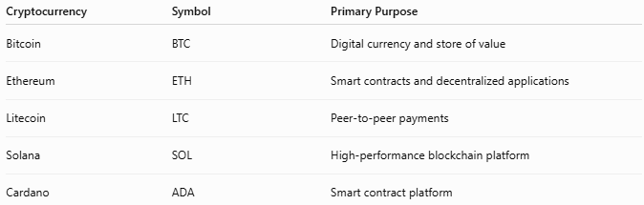
Cryptocurrency | Symbol | Primary Purpose
Bitcoin | BTC | Digital currency and store of value
Ethereum | ETH | Smart contracts and decentralized applications
Litecoin | LTC | Peer-to-peer payments
Solana | SOL | High-performance blockchain platform
Cardano | ADA | Smart contract platform

Consensus Mechanisms
# Source: AI Source: Provided by: [Data Path: Persons Table -> ID Column: 1, Name_En Column: Motasem Essam] -> From: [ChatGPT] on [7/17/2026]
Cryptocurrency networks use different methods to validate transactions.
Proof of Work (PoW)
Participants called miners solve computational problems to validate transactions.
Example:
- Bitcoin

Proof of Stake (PoS)
Participants called validators are selected based on cryptocurrency they have committed (staked) to the network.
Example:
- Ethereum

Applications
# Source: AI Source: Provided by: [Data Path: Persons Table -> ID Column: 1, Name_En Column: Motasem Essam] -> From: [ChatGPT] on [7/17/2026]
Cryptocurrencies are used for:
- Digital payments
- International money transfers
- Investment
- Decentralized Finance (DeFi)
- Smart contracts
- Digital asset ownership
- Blockchain applications

Advantages
# Source: AI Source: Provided by: [Data Path: Persons Table -> ID Column: 1, Name_En Column: Motasem Essam] -> From: [ChatGPT] on [7/17/2026]
Cryptocurrency offers:
- Peer-to-peer transactions.
- Global accessibility.
- Transparent blockchain records.
- Programmable financial services.
- Reduced dependence on intermediaries.

Limitations
# Source: AI Source: Provided by: [Data Path: Persons Table -> ID Column: 1, Name_En Column: Motasem Essam] -> From: [ChatGPT] on [7/17/2026]
Cryptocurrencies may involve:
- Significant price volatility.
- Regulatory uncertainty.
- Cybersecurity risks.
- Responsibility for protecting private keys.
- Potential transaction fees depending on network activity.

Cryptocurrency vs. Fiat Currency
# Source: AI Source: Provided by: [Data Path: Persons Table -> ID Column: 1, Name_En Column: Motasem Essam] -> From: [ChatGPT] on [7/17/2026]
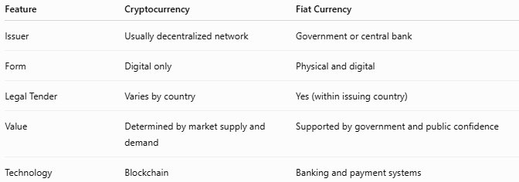
Feature | Cryptocurrency | Fiat Currency
Issuer | Usually decentralized network | Government or central bank
Form | Digital only | Physical and digital
Legal Tender | Varies by country | Yes (within issuing country)
Value | Determined by market supply and demand | Supported by government and public confidence
Technology | Blockchain | Banking and payment systems

Cryptocurrency vs. Digital Currency
# Source: AI Source: Provided by: [Data Path: Persons Table -> ID Column: 1, Name_En Column: Motasem Essam] -> From: [ChatGPT] on [7/17/2026]
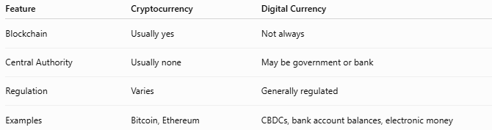
Feature | Cryptocurrency | Digital Currency
Blockchain | Usually yes | Not always
Central Authority | Usually none | May be government or bank
Regulation | Varies | Generally regulated
Examples | Bitcoin, Ethereum | CBDCs, bank account balances, electronic money

Security Features
# Source: AI Source: Provided by: [Data Path: Persons Table -> ID Column: 1, Name_En Column: Motasem Essam] -> From: [ChatGPT] on [7/17/2026]
Cryptocurrencies use:
- Public-key cryptography
- Private keys
- Digital signatures
- Distributed blockchain networks
Protecting private keys is essential because losing them may permanently prevent access to the cryptocurrency.

Common Mistakes
# Source: AI Source: Provided by: [Data Path: Persons Table -> ID Column: 1, Name_En Column: Motasem Essam] -> From: [ChatGPT] on [7/17/2026]
- Confusing cryptocurrency with all digital currencies.
- Assuming cryptocurrencies are anonymous (many blockchains are publicly traceable).
- Believing cryptocurrencies are legal tender in every country (their legal status differs by jurisdiction).
- Assuming cryptocurrency transactions can always be reversed (many are irreversible once confirmed).

Interesting Facts
# Source: AI Source: Provided by: [Data Path: Persons Table -> ID Column: 1, Name_En Column: Motasem Essam] -> From: [ChatGPT] on [7/17/2026]
- Bitcoin, introduced in 2009, was the first widely adopted cryptocurrency.
- Thousands of cryptocurrencies exist today, although only a smaller number have broad adoption or significant market value.
- Blockchain technology is also used in supply chains, digital identity systems, healthcare, and record management.

Key Points
# Source: AI Source: Provided by: [Data Path: Persons Table -> ID Column: 1, Name_En Column: Motasem Essam] -> From: [ChatGPT] on [7/17/2026]
- Cryptocurrency is a type of digital currency secured by cryptography.
- Most cryptocurrencies operate on blockchain technology.
- They are stored in digital wallets.
- Major examples include:
  - Bitcoin (BTC)
  - Ethereum (ETH)
  - Litecoin (LTC)
  - Solana (SOL)
- Cryptocurrencies generally differ from government-issued currencies because they are not issued or controlled by central banks.

Conclusion
# Source: AI Source: Provided by: [Data Path: Persons Table -> ID Column: 1, Name_En Column: Motasem Essam] -> From: [ChatGPT] on [7/17/2026]
Cryptocurrency is a modern form of digital currency that uses cryptography and blockchain technology to enable secure, decentralized financial transactions. By allowing value to be transferred directly between users without relying on a central authority, cryptocurrencies have introduced new possibilities for payments, investment, and decentralized applications. At the same time, they present unique challenges, including price volatility, regulatory differences, and security responsibilities, making them fundamentally different from traditional government-issued currencies.

